A new life

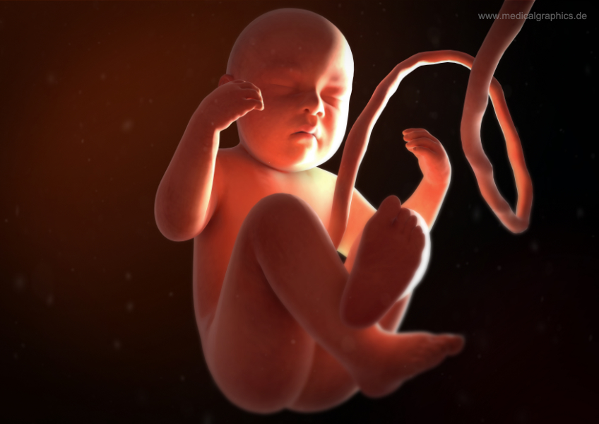

As a fetus grows and develops in the uterus it must be provided with substances it needs to stay alive and the materials needed for growth. These requirements are met by the placenta, amniotic fluid and umbilical cord.

To do in your group
You have been given some cards.
Your task is to sort them into two groups:
- one group for functions of the amniotic fluid
- one group for functions of the placenta.

To talk about in your group
- A younger student asks you to explain how a developing fetus breathes and gets oxygen. How would you answer this question?
- A younger student asks you to explain how a developing fetus eats. How would you answer this question?
- A younger student asks you to explain how a developing fetus stays warm. How would you answer this question?

Biology > Big idea: Heredity and life cycles > Topic BHL3: Reproduction > Key concept BHL3.1: Sexual reproduction in humans
Response activity
A new life

Overview
Learning focus: | The human male and female reproductive systems produce and release gametes which come together during sexual reproduction, and if an ovum is fertilised by a sperm a fetus develops in the uterus of the female.
Observable learning outcome: | Describe the role of the umbilical cord, placenta and amniotic fluid in fetal development.
Activity type: | Discussion, card sort
Key words: | amniotic fluid, placenta, umbilical cord, fetus, pregnancy, gestation, reproduction

This activity can help develop students’ understanding by addressing the sticking-points revealed by the following diagnostic question:
- Diagnostic question: Developing needs
What does the research say?
It would seem that children have a desire to know more about the development of the embryo and fetus following conception and implantation. Children participating in Zimvrakaki (2004) research into children’s representations about their body and sexual development requested more information about the reproductive system and the development of the embryo, listing information on how the embryo breaths and gets air as being one area where they felt their knowledge was lacking.
Franse et al. (2009) conducted a study on children’s thoughts on unborn babies, and noted that literature on children’s preconceptions on fetal development is scarce. Their study examines whether children have a coherent, naïve theory or fragmented knowledge of prenatal development, and concludes that children have a more coherent theory for changing morphology than for changing bodily function, with the latter being more fragmented. Topics investigated in the bodily function aspect of the research related to breathing, drinking and maintaining body temperature.
Ways to use this activity
Students should complete this activity in pairs or small groups. The focus of the activity should be on group discussion to decide how to sort the cards into the required groups and answer the questions that follow.
It is through the discussions that students can check their understanding and develop their explanations. Listening in to the conversations of each pair/group will often give you insights into how your students are thinking. The quality of the discussions can be improved with a careful selection of pairs/groups, or by allocating specific roles to students in each pair/group. For example, you may choose to select a student with strong prior knowledge as a scribe, and forbid them from contributing any of their own answers; they may question the others and only write down what they have been told. This strategy encourages contributions from more members of each group.
After their discussions, each pair/group should be prepared to report the key points of their discussion to another pair/group, or to the class.
Differentiation
You may choose to read the instructions and questions to the class, so that everyone can focus on the science. In some situations it may be more appropriate for a teaching assistant to read for one or two students.
Equipment
For each pair/group:
- cards, printed and cut out from the end of this document
Expected answers
Placenta statements
- Provides some protection against disease, particularly bacteria, but not viruses.
- Receives waste such as carbon dioxide from the fetus via the umbilical cord.
- Passes oxygen and nutrients to the baby via the umbilical cord.
- Keeps the mother and fetal blood supply separate.
- Produces hormones that help the fetus grow and develop.

Amniotic fluid statements
- Cushions the developing fetus from bumps and injury.
- Maintains a constant temperature for the developing fetus.
- Helps the development of the lungs, digestive system and musculoskeletal system.
- Fetus can inhale fluid in later pregnancy (breathing practice).
- Small amounts of urine are released by the fetus into this area.
Questions
The questions require students to piece together the role of the placenta, umbilical cord and amniotic fluid to answer some questions on the bodily functions of the fetus. These questions provide an opportunity to see if students have made the link between the structures and understand how these functions are achieved.
Ideas that should be seen in students’ answers to these questions include:
- The fetus does not breathe air in the way a newborn baby breathes. The oxygen that is required to sustain life is provided by the mothers’ blood. This blood does not enter the fetus, instead the placenta is involved in the exchange of oxygen from the maternal blood to the fetal blood. The fetal haemoglobin is different from maternal haemoglobin – it has a higher affinity for oxygen. The oxygen attached to the mother’s haemoglobin is released and attaches to the fetal haemoglobin and the umbilical cord acts as a connector to take the blood to the fetus.
- The feus does not eat. The mother eats and the nutrients are absorbed into her blood. These nutrients are exchanged and given to the fetus by the placenta.
- The amniotic fluid surrounds the fetus. This stays at a constant temperature, keeping the fetus at body temperature during pregnancy.
Acknowledgments
Developed by Elizabeth Lupton (UYSEG).
Images: MedicalGraphics (www.medicalgraphics.de/en/free-pictures/free-pictures/miscellaneous/fetus-front.html)
References
Franse, R. R., Maartje., Van Es, S. E. and Van Schijndel, T. J. P. (2009). Children's thoughts on unborn babies. Representational redescription in preconceptions of children on fetal development. Proceedings of the Annual Meeting of the Cognitive Science Society, 31(31).
Zimvrakaki, E. and Athanasiou, K. (2004). Children's representations about their body and sexual development. ERIDOB. Patras- Greece: Patras University Press.

Print and cut out cards for card-sort activity

Provides some protection against disease, particularly bacteria, but not viruses. | Receives waste such as carbon dioxide from the fetus via the umbilical cord. | Small amounts of urine are released by the fetus into this area. | Cushions the developing fetus from bumps and injury.
Passes oxygen and nutrients to the baby via the umbilical cord. | Maintains a constant temperature for the developing fetus. | Keeps the mother and fetal blood supply separate. | Helps the development of the lungs, digestive system and musculoskeletal system.
Fetus can inhale fluid in later pregnancy (breathing practice). | Produces hormones that help the fetus grow and develop.

